1.3 Set Up and Configure GitHub Account

This section will guide you to:

* Create your GitHub account
* Connect local Git repository to remote GitHub via SSH
* Initiate the first push

This guide has four subsections, namely:

1.3.1 Setting up your GitHub account

1.3.2 Creating SSH-key and adding it to GitHub

1.3.3 Logging at local Git to connect with remote GitHub

1.3.4 Creating a repository in your GitHub account

**Step 1.3.1:** Setting up your GitHub account.

**About GitHub:** It is a web-based hosting service for version control using Git. It offers plans for public and private repositories. You can add multiple projects by creating multiple public repositories. In this section, we will only demonstrate how public repository works.

* Navigate to https://github.com/ and click on **Sign up for GitHub**. Enter the details and click on **Create an account**.

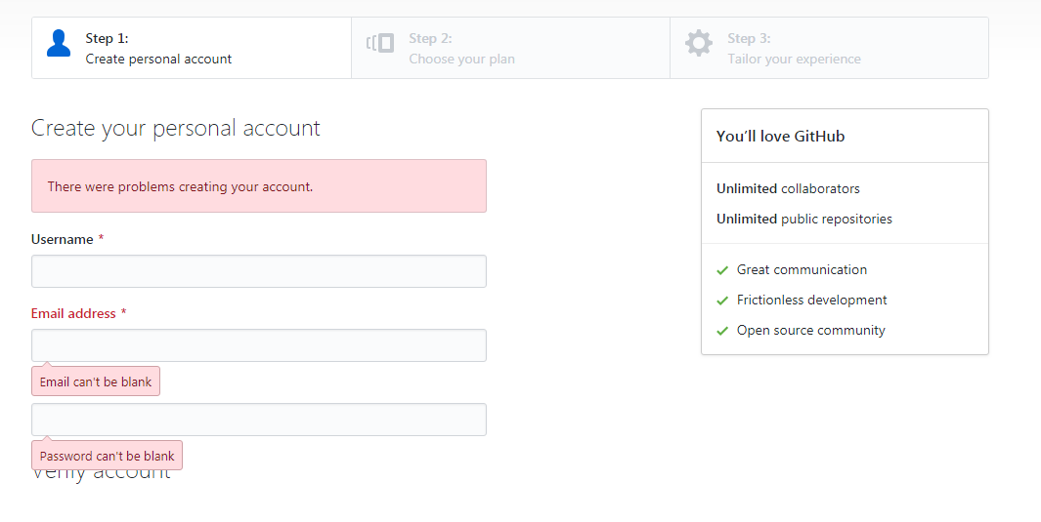

* Once you’re at **Step 2: Choose your personal plan**, Select **Free,** and click on **Continue**. You can share basic information about yourself or you can select **skip this step**.
* You must have received an email to confirm your account. It is important to confirm your account before you use GitHub. Once you have confirmed, you are successfully signed for GitHub.

**Step 1.3.2:** Creating an SSH Key and adding it to GitHub.

You can create ssh-key via **Git bash** by following the below steps:

* Open your **Git bash**
* Execute the command: 

ssh-keygen -t rsa -b 4096 -C “<your email address>” 🡪 press [enter]

* Do not type anything, but press enter until the setup is complete.
* Start the ssh-agent in the background:

eval $(ssh-agent -s)

* Add your SSH private key to the ssh-agent:

ssh-add ~/.ssh/id_rsa

* Copy the SSH key to your clipboard:

clip < ~/.ssh/id_rsa.pub

* Copy the entire key from the clipboard. Choose ***Your avatar* > settings** > **SSH & GPG Keys,**click on **New SSH** **key** and paste the key. Click on **Save.**

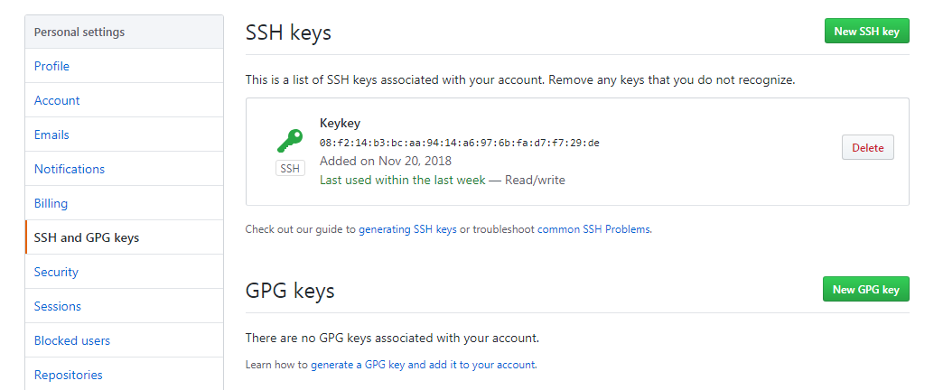

**Step 1.3.3:** Logging at local Git to connect with remote GitHub.

* Open the Git terminal and execute the below commands by replacing **your_Email_Id** with your registered email address with GitHub and replace **Your_Username** with your GitHub username.

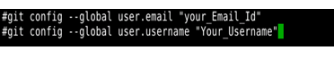

**Step 1.3.4:** Creating a repository in your GitHub account.

* Go to the homepage of GitHub.com and click on **New Repository** as shown below:

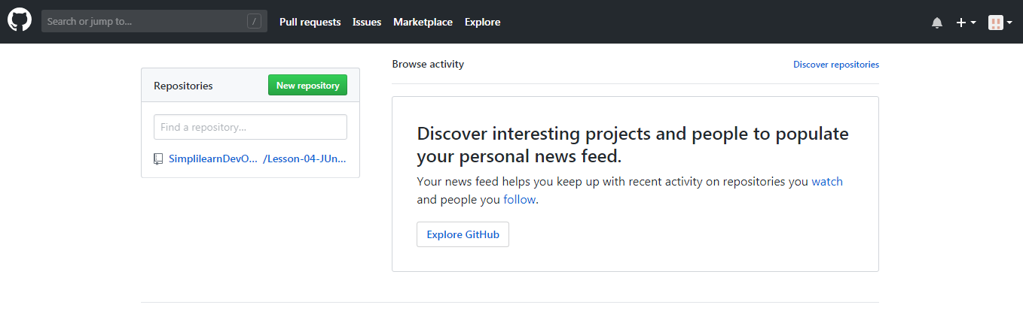

* Enter the file name and click on **Create repository** as shown in the example screenshot below:

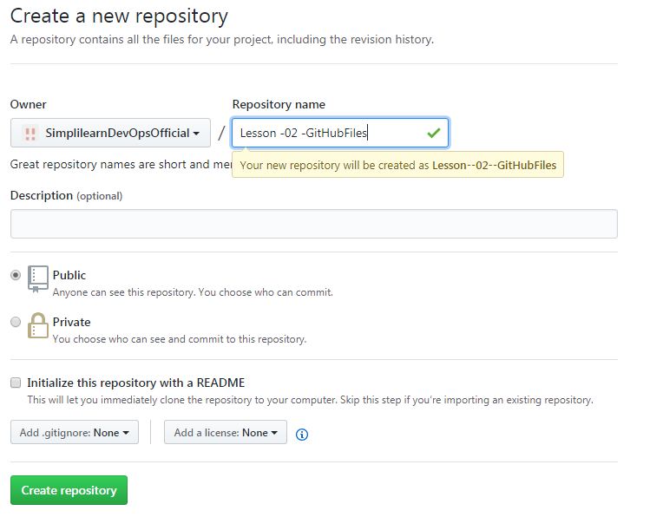

* You will be redirected to a quick guide page and inside the directory you have created.

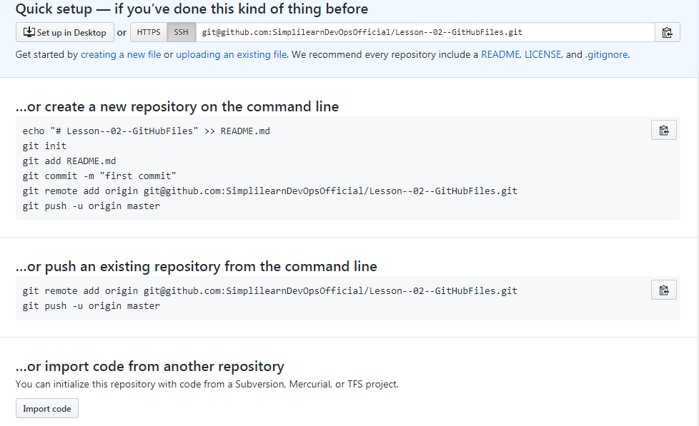

* Since a repository is already created, **“…or create a new repository on the command line**” should be skipped. Click on **SSH** to change the instructions from **HTTPS** to **SSH** (if you’re using Ubuntu).
* Copy the **git remote add origin <URL_of_Your_GitHub_Repository>** and execute it in the terminal as shown in the example command below:

git remote add origin git@github.com:SimplilearnDevOpsOfficial/Lesson--02--GitHubFiles.git

git push -u origin master